CTG AQF3 Assessment December 2019
(26.11.19 edits)

Assessment

Competency Based Assessment
Competency based assessment is the process of gathering evidence to confirm that participants can perform required skills and knowledge. To complete a unit of competency participants are required to successfully demonstrate their skills and knowledge on all of the activities within this assessment. Rather than using a marking scale, competency based assessment uses competent or not yet competent.

You are required to successfully demonstrate competence in all of the activities in this assessment. This means that if you are unable to answer a question, your answer is deemed not satisfactory for any of the activities or you are unable to demonstrate a practical skill your assessor will work with you to identify opportunities for further learning if required and arrange re-assessment when you are ready.

In the event that you are unable to demonstrate your ability in any area of the assessment you will re-assessed. Re-assessment may include demonstrating a skill, answering questions, providing further information. All participants are given two (2) opportunities to be reassessed without further payment required. On the occasions were participants are unable to demonstrate competency after two (2) re-assessment attempts they should speak to their trainer about further opportunities to complete the unit.

Individual workplaces
We are aware that the answers, information and projects completed by students will differ from one workplace to another and we encourage you were ever possible to apply the requirements of your assessments to your workplace. We are not assessing your ability against anyone else and we do not compare your work to that of other students to determine if you are competent or not. When assessing your ability to demonstrate the skills and knowledge of this unit your assessor is looking only at your ability against the requirements of the unit.

In the event that your workplace does not have the required documents, resources and/or equipment to undertake the learning and assessment activities in a unit, we will provide access to these for you.

You will find that when you are required to provide work samples the activity asks you to use your workplaces template, forms, checklists and policies. In the event that your workplace does not have these we will provide examples that you can work with.

The assessment requires you complete three (3) different assessment tasks: questions, activities and practical.

Questions
You are required to answer the questions in your own words to demonstrate understanding. Most questions require short answers or lists. Questions can also be completed orally. In the event of oral assessment you are required to answer the question in your own words and your assessor or other support person is required to document your answers.

Activities

The activities require students read the case studies and complete the work documents provided in relation to the case study.

Practical
The practical assessments provide you with the opportunity to demonstrate specific skills. The practical assessments for this unit can be observed by our assessor face to face or recorded and submitted to your assessor for marking.

Notes regarding the assessment
- Students are required to keep a copy of their assessment.
- Students are required to clearly indicate which assessment section or question is being addressed.
- Please note we will keep your assessment on file and it will not be returned to you.
- Please make sure that you fill in your name, sign, date and attach the cover page to your assessment. Indicate which activities have been attached to the cover page.

Feedback
Students will be given feedback on all assessment activities within 10 days of receiving your assessment. Competency based assessment does not use a marking scale rather the student is deemed competent or not yet competent. Students deemed not yet competent are given additional opportunities to demonstrate competency.

Satisfactory demonstration of all activities is required before competency is achieved for the unit. In the event that you have not been able to successfully demonstrate competence in the unit, your assessor will discuss options for re assessment with you.

Plagiarism
Plagiarism is a form of cheating. It is taking and using someone else’s thoughts, writings or inventions and representing them as your own. Plagiarism is a serious act and may result in a participant’s exclusion from a module or a course. When you have any doubts about including the work of other authors in your assessments, please consult with your facilitator.

The following list outlines some of the activities for which a participant can be accused of plagiarism:
- Presenting any work by another individual as one’s own unintentionally
- Handing in assessments markedly similar to or copied from another student
    - Presenting the work of another individual or group as their own work.
    - Handing in assessments without the adequate acknowledgement of sources used, including assessments taken totally or in part from the internet.

What about Copyright?
You must be careful when using work from others. Copyright covers all work that is not your own including textbooks, newspapers, website information, music, magazines, movies etc.

You are allowed to do a certain amount of copying for research or study purposes. Generally, 10% or one chapter of a book is acceptable, where the participant is studying with or employed by an educational institution. All material taken from another source, word for word or paraphrased, must be acknowledge using an acceptable referencing system.

Assessment Cover Sheet
Units |  | AHCCHM307 - Prepare and apply chemicals to control pest, weeds and diseases and AHCCHM304 Transport and store chemicals
Assessment Activities |  |  | Satisfactory (S) |  | Not Satisfactory (NS)
Activity 1: Questions
Activity 2: Activities and spray plan
Activity 3: Practical assessment
Assessor Feedback
Overall Assessment Outcome |  |  |  | Competent |  |  | Not Yet Competent
AHCCHM307 - Prepare and apply chemicals to control pest, weeds and diseases and AHCCHM304 Transport and store chemicals
Assessor: |  |  |  | Date:
Signature:

Resubmission arrangements if NYC
Comments:
Date resubmission completed: | DD | MM | YY

Practical Assessment Checklist – Trainer to complete
Student’s Name
Assessor’s name
Satisfactory | Yes No Date:
Did the student? | Yes | No
Transport chemicals
- Check emergency services contact information is inside the vehicle
- Check that the emergency equipment and procedures are in the vehicle
- What do you check to be sure the vehicle complies with transport regulations?
- Load the vehicle ensuring:
- All containers are closed before loading
- No chemicals are placed in the cab
- Containers are secured
- Heavy containers are placed at the bottom
- Light objects placed on top
- Separation and segregation rules are followed
- The load is protected
- Chemicals are secured so they can’t move or fall
- Confirm Safety Data Sheets are available for each chemical being transported
- Handle and load hazardous chemicals safely:
- Using PPE
- Following manual handling requirements
- According to label requirements
- Complete Work Workplace safety transport incident
Prepare and apply chemicals
- Student to select:
What is to be treated

Chemical to be used
- Discuss why chemical to be used is most appropriate
- Select and fit PPE to undertake task
- Access chemical for preparation
- Identify and select application equipment and set up requirements
- Apply control measures to reduce risk while preparing chemicals for application
- Prepare chemicals:
- Select mixing equipment
- Select suitable location to prepare chemicals
- Load chemicals in a safe manner according to label instruction
- Clean preparation equipment
- Clean work site of spillage and residue

17.Check chemical expiry dates and identify expired chemicals

18.Return unused chemicals to storage according to product label
- Discuss the process for disposal of expired chemicals:
- Discuss are there any re entry or withholding periods using this chemical? Referencing label and SDS
- Select application equipment:
- Select equipment compatible with Property Spray Plan
- Equipment selected is most appropriate to reduce off target spray risk
- Conduct pre-operational checks of application equipment:
- Calibrate application equipment:
- Load equipment with chemical according to:
- Operating instructions
- Safety points to be followed and observed
- Check weather conditions:
- Apply chemicals according to:
- Product label instructions
- Property Spray Plan
- Most effective for plant, pest or weed being treated
- Safety
- Monitor application equipment for effective performance and chemical application
- Implement hazard and risk controls when applying chemicals
- How would you clean a spill if it occurred while applying tis chemical?
- Complete spill incident form
- Discuss how you would dispose of chemicals and empty containers according to:
- Label instructions
- Safety data sheets
- Legislative requirements
- Clean and decontaminate applicator equipment according to:
- Operator instructions
- Safety data sheets
- Legal requirements including add specifics relating to legislation
- Clean and store PPE
- Discuss the best way to maintain storage area:
Signed by assessor: _______________________ Date: _____________

Feedback/Comments:

Activity 1: Questions

Instructions to Student

This section requires you to answer multiple choice questions and short answer questions. Questions 9 to 19 in the regulatory section, requires you answer the questions relevant to your State or Territory. In the pests section, you need to answer Pest/weed/disease identification and control option 1 or option 2. All other questions are to be answered.

Multiple choice questions: Indicate the correct answer/s to the multi choice questions. Some questions have more than one correct answer. You must indicate all correct answers. There are also short answer questions in this section.

Short answer questions: The following questions are to be answered by you in the space provided. The length of the answer for each question is indicated.

Regulatory

1. Which Federal body registers and approves pesticides labels?

a) The Prime Minister’s Office

b) Work Safe Australia

c) Environmental Protection Authority (EPA)

d) Australian Pesticide and Veterinary Medicines Authority (APVMA)

2. APVMA Permits allow for “off-label” use of chemicals. All of the following are part of the permits scheme EXCEPT:

a) minor use permits which apply to situations usually involving new crops, low acreage or small portions of high acreage crops not listed on the label

b) Emergency use permits such as outbreaks of exotic diseases or pests

c) Trial permits which allow for chemical products to be used in research trials of varying size for scientific purposes

d) High Dose Permits allowing the use of a rate higher than indicted on the label

3. Which of the following are NOT part of your “Duty of Care” obligation when using chemicals?

a) Ensuring you have the newest spray technologies at your workplace

b) Avoiding harm/injury to self, others, property or the environment

c) Undertaking duties in a manner that is safe

d) Storing chemicals safely and securely

4. Which of the following are obligations of workers under the Workplace Health and Safety Act?

a) Cooperate with employers in their efforts to comply with the legislation

b) Use safety equipment, follow safety procedures and report risks to management

c) Disclose medications which may impact on performance and safety

d) Participate in training and use PPE as directed

e) all of the above

5. All EXCEPT ONE of the following are regarding as sensitive places and require special care (and notification) when spraying nearby:
- School, preschool or kindergarten
- Hospital
- Community health centre or nursing home
- National Parks
- Adjacent cropping farm with the same crops as those to be sprayed

6. Identify ALL persons from the following list that must give notice

a) Public authorities such as local councils, spraying parks and ovals

b) Property managers and pest management technicians when spraying common areas

c) Spray contractors spraying individual dwellings

d) Spray contractors, when using chemicals adjacent to schools

7. Which of the following is NOT a restricted product (RCP)

a) 1080

b) Rabbit haemorrhagic disease (RHD) or rabbit calicivirus disease (RCD)
c) Glyphosate

d) Pindone concentrate

8. For 1080 use, which of the following statements is INCORRECT?

a) All neighbours within 1 km of the property being treated must be notified at least 72 hours before baiting

b) 1080 represents a low level of risk of toxic hazard to humans

c) Warning signs must displayed at all entry points

d) Baits must not be laid on any stock route or reserve without government approval

Complete at least ONE states set of legislation questions- preferably the state you work in. If you work in multiple states, it is recommended you complete all the legislation sections YOU work in.

NSW LEGISLATION:

9. Which state government office looks after pesticide use in NSW?

a) Land and Water Conservation

b) Department of Agriculture, Forestry and Fisheries

c) Office of Environmental and Heritage (EPA)

d) SafeWork NSW

10. Indicate the main Act that relates to pesticide spraying in NSW

a) Rural Lands Protection Act 1998

b) Pesticides Act 1999

c) The Stock and Diseases Act 1923

d) SafeWork NSW

11. Indicate the regulation that requires placarding for transport of chemicals AND the regulation regarding placard requirements for storage of chemicals

a) Rural Lands Protection Act 1998

b) Dangerous Goods (Road and Rail Transport) Regulation 2014 [NSW].

c) The Stock and Diseases Act 1923

d) Work Health and Safety Regulation 2017 (NSW)

QLD LEGISLATION:

12. Which state government office looks after pesticide use in QLD?

a) Land and Water Conservation

b) Department of Agriculture and Fisheries

c) Environmental Protection Agency

d) SafeWork QLD

e) Workcover QLD

13. Which of the following Acts DOES NOT relate to pesticide spraying in QLD:

a) Agricultural Chemicals Distribution Control Act 1966 and Regulation 1988

b) Agricultural and Veterinary Chemicals Code Act 1994 and Regulation 1995

c) Land Act 1994

d) Work Health and Safety Act 2011

e) Chemical Usage (Agricultural and Veterinary) Control Act 1988

14.Which of the following is NOT a requirement of the Chemical Usage (Ag and Vet) Control Act 1988?
- Only use pesticides registered by the APVMA
- Chemicals can be recalled if deemed necessary based on risk, non compliance or poor stewardship
- Not to decant (transfer) pesticide into food and beverage containers
- Not to detach or deface the label in any way
- To increase the chemical label rate if a resistance problem is suspected

SA LEGISLATION:

15. Which state government office looks after pesticide use in SA?
- Land and Water Conservation
- Cooperative Research Centre
- Office of Environment and Heritage EPA
- PIRSA, Rural Chemicals Operations
- SafeWork SA

16. What is the main Act that relates to pesticide spraying in SA?
- SA Occupational Health, Safety and Welfare Act 1986
- Agriculture and Veterinary Products (Control of Use) Act 2002
- The Livestock Act 1997
- Public and Environmental Health Act 1987
- The Prevention of Cruelty to Animals Act 1979

17.Which of the following statements regarding pesticide usage in SA is false (choose only one):
- Under current SA legislation a product can be used on a crop or animal following the label directions for another state if there are no directions for SA
- Livestock that has been treated with a chemical can be sold before the withholding period expires, as long as the purchaser is notified in writing of product(s) used, date used and withholding period(s).
- Legal action can be taken against a person who causes spray drift
- I can legally ignore my boss if he/she asks me to wear a respirator when using a hazardous chemical at work.
- If I apply chemicals to my neighbour’s crop in exchange for a half side of beef from my neighbour, I should have a spray contractor’s licence (ie a Pest Controller’s Licence and a Pest Management Technician’s Licence).

VIC LEGISLATION:

18.Which state government office looks after pesticide use in VIC?
- Land and Water Conservation
- Cooperative Research Centre
- EPA
- Department of Jobs, Precincts and Regions (DJPR)
- WorkCover
19. What is the main Act that relates to pesticide spraying in VIC?
- The Dangerous Goods Act 1985
- The Health Act 1958
- Catchment and Land Protection Act 1994
- Agricultural and Veterinary Chemicals (Control of Use) Act 1992
- Road Transport (Dangerous Goods) Act 1995

WA LEGISLATION:
20. Which state department looks after pesticide control of use in WA to protect human health?
- Department of Biosecurity
- Department of Health
- WorkCover
- Environmental Protection Agency WA

21. Which of the following statements concerning AgVet chemicals and all aspects of transport, storage and use in the state is false?
- The Department of Health (DOH) looks after the transport, storage and handling of pesticides that are Dangerous Goods
- The Agriculture and Related Resources Protection [Spraying Restrictions] Regulations restrict the application of 2,4-D HVE in the Swan Valley, Geraldton and Kununurra areas and on all other areas within 10km of a commercial vineyard or tomato garden.
- Training is mandatory for anyone who applies a hazardous substance (under OSH legislation), handles and/or stores a dangerous good in a rural dangerous goods location, Licensed Pest Management Technicians and Aerial Spraying Operators
- Under Occupational Health and Safety legislation Commercial spray operators must make and keep spray records for 2 years.
- The Poisons Act 1964 allocates chemicals into eight schedules based on human toxicity and hazard

TAS LEGISLATION:

22. Which state government office looks after pesticide use in Tasmania?
- Land and Water Conservation
- Department of Health
- Environmental Protection Agency
- Agricultural and Veterinary (AgVet) Chemical Program within DPIPWE
- WorkSafe Tasmania

23. What is the main Act that relates to pesticide spraying in Tasmania?
- Occupational Health and Safety Act 2004
- Agricultural and Veterinary Chemicals (Control of Use) Act 1995
- Animal Health Act 1995
- Public Health Act 1997
- Animal Welfare Act 1993
25.Which of the following statements regarding pesticide usage in Tasmania is FLASE:
- A person who applies chemical products for a licensed Commercial Operator must have a Certificate of Competency that is relevant to the type of work they perform.
- Legal action can be taken against a person who causes spray drift onto a neighbours sensitive crops
- I can legally ignore my boss if he/she asks me to wear a respirator when using a hazardous chemical at work.
- If I apply chemicals to my neighbour’s crop in exchange for a half side of beef from my neighbour, I don’t need to be licensed
- 2,4D can be applied all year round without a permit as long as it is a salt; not an ester formulation.

Pests
- Complete the table below, detailing how each control method works in controlling plant pests, disease and weed infestations
Control Methods | Example | How these work in controlling plant pests, disease disorders
Biological control
Cultural control
Mechanical and physical control
Chemical control

- Draw a line to match the control to the examples below:
- Use of the mouldboard plough to control annual ryegrass and wild radish by deep burial to 30 cms.
- Planting amenity areas in Australian natives rather than European plants given the natives are more suited to local conditions
- Using the Cactoblastis moth to control Prickly Pear

- Glyphosate herbicide on annual weeds like capeweed and spear thistles around buildings

Biological control

Cultural control

Mechanical and physical control

Chemical control

- Describe four (4) principles that would be required to improve resistance management?

_______________________________________________________________________________________________________________________________________________________________________________________________________________________________________________________________________________________________________________________
- (a) What is the purpose of Integrated Pest Management in agriculture?

__________________________________________________________________________________________________________________________________________________________________________________________________________________________________________

b) What are two (2) examples of an Integrated Pest Management (IPM) strategy?
_________________________________________________________________________________________________________________________________________________________________________________________________________________________________________
- Fill in the table below with the mode of action (MOA) and chemical characteristics:

Category | MOA example | Chemical characteristics
Contact
Selective
Translocated / Systemic
Residual
Ingested poison
Knock down / non selective
Protectant
Eradicate Curative

Answer the questions for either Pest/weed/disease identification and control 1 (Broadacre based) OR Pest/weed/disease identification and control 2 (Amenity based).
- Pest/weed/disease identification and control 1:
- Identify the Pest/weed/disease in the image below

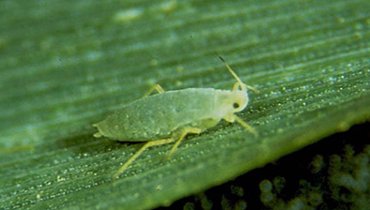

________________________________________________________________________
- What characteristics of this Pest/weed/disease helped you identify it?

________________________________________________________________________

________________________________________________________________________

- What type of crop damage can this Pest/weed/disease cause?
________________________________________________________________________

________________________________________________________________________

- When would you need to control this Pest/weed/disease (damage/action threshold or point in pest/weed/diseases lifecycle)?

________________________________________________________________________

________________________________________________________________________

- What is a non-chemical control that can be used for this Pest/weed/disease?

________________________________________________________________________

________________________________________________________________________

- What is an example of a chemical control that can be used for this Pest/weed/disease?
________________________________________________________________________

- Based on the chemical you answered for question f above, what is this products mode of action?

________________________________________________________________________

________________________________________________________________________

- Does this Pest/weed/disease have any resistance to chemical controls? If yes, what are they?

________________________________________________________________________

- How would you decide to use a chemical control instead of a non-chemical control?

________________________________________________________________________

________________________________________________________________________
________________________________________________________________________

________________________________________________________________________

- Pest/weed/disease identification and control 2:
- Identify the Pest/weed/disease in the images below
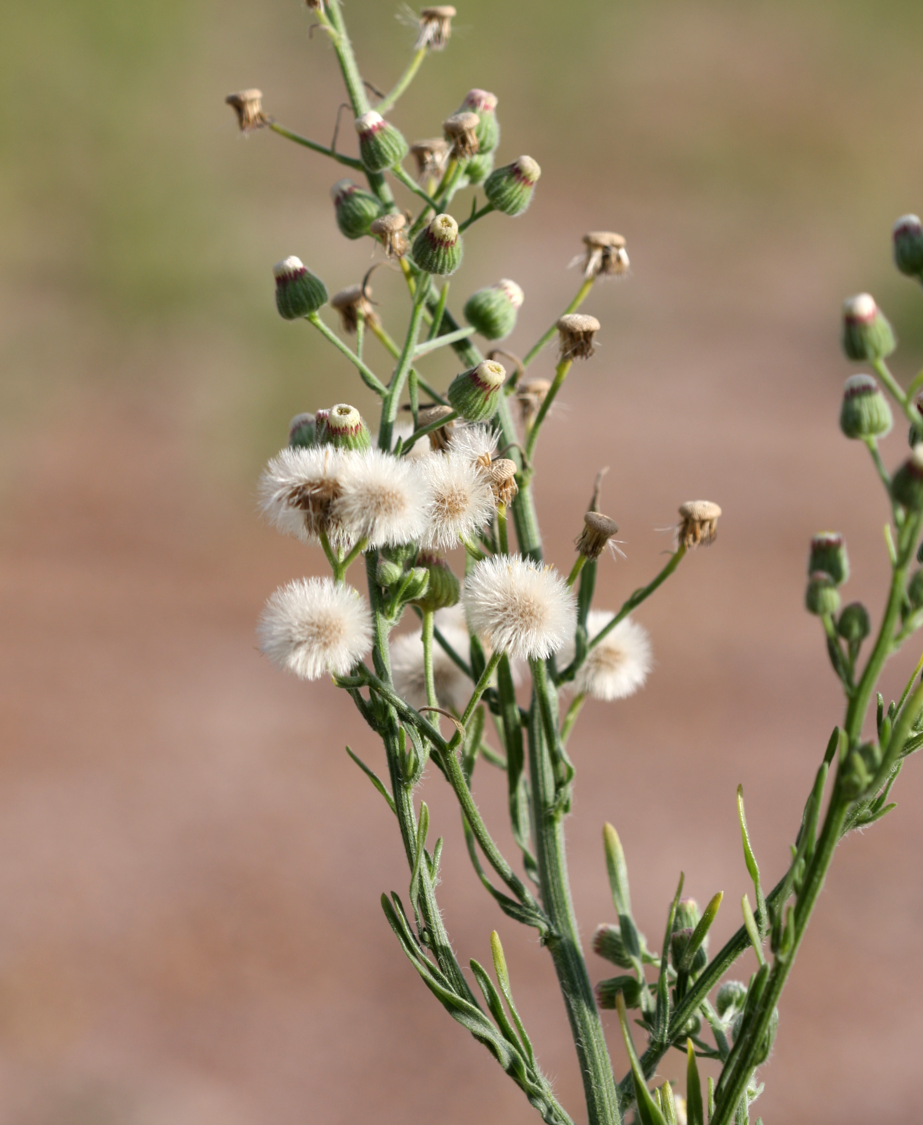
Photo: WeedSmart
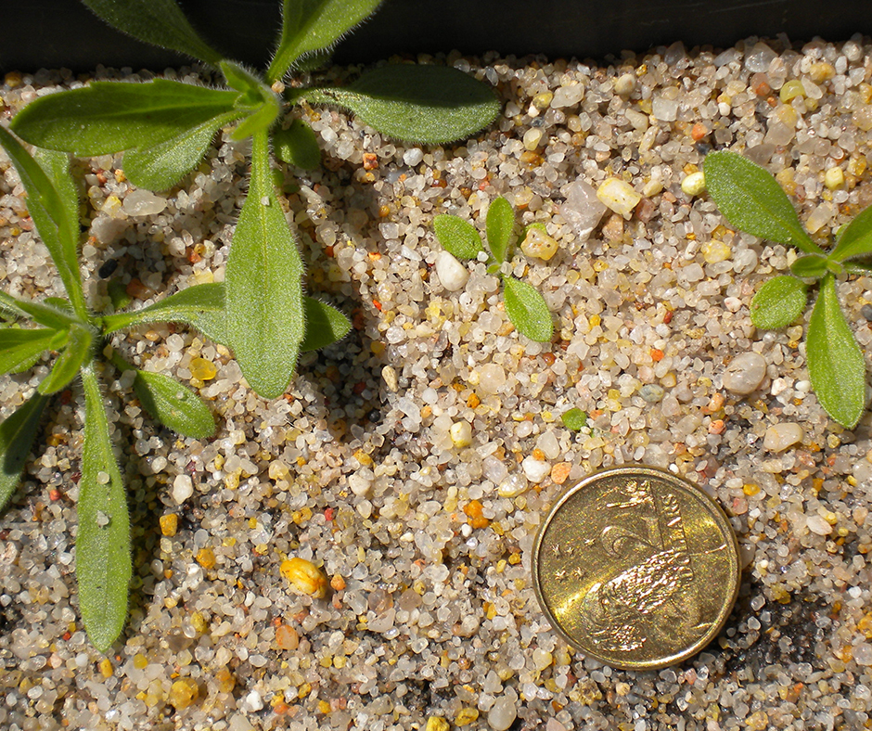

________________________________________________________________________
- What characteristics of this Pest/weed/disease helped you identify it?

________________________________________________________________________

________________________________________________________________________

- What type of crop damage can this Pest/weed/disease cause?
________________________________________________________________________

________________________________________________________________________

- When would you need to control this Pest/weed/disease (damage/action threshold or point in pest/weed/diseases lifecycle)?

________________________________________________________________________

________________________________________________________________________

- What is a non-chemical control that can be used for this Pest/weed/disease?

________________________________________________________________________

________________________________________________________________________

- What is an example of a chemical control that can be used for this Pest/weed/disease?
________________________________________________________________________

- Based on the chemical you answered for question f above, what is this products mode of action?

________________________________________________________________________

________________________________________________________________________

- Does this Pest/weed/disease have any resistance to chemical controls? If yes, what are they?

________________________________________________________________________

- How would you decide to use a chemical control instead of a non-chemical control?

________________________________________________________________________

________________________________________________________________________
________________________________________________________________________

________________________________________________________________________

Label, SDS & Signage
- What is the purpose of chemical labels?
________________________________________________________________________

________________________________________________________________________

________________________________________________________________________

- What is the purpose of Safety Data Sheet (SDS)?
________________________________________________________________________

________________________________________________________________________

________________________________________________________________________

35. Where can you access the procedures for using chemicals (SELECT ONE)?

a) Workplace procedural manual

b) Product label

c) Safety Data Sheets

d) Follow what others are doing

36.Where do you find information about the safe storage of chemicals?
________________________________________________________________________

________________________________________________________________________

37. What is a “withholding period”?

a) minimum period of time that must elapse between the last application of an agricultural or veterinary (AgVet) chemical product to a crop/animal before harvest or slaughter/milking

b) refers to the minimum period of time which must elapse between the application of a chemical product, and re-entry of people to the treated area

c) refers to the minimum amount of time before a person using PPE can revisit the site

d) all of the above

38. What is a “re-entry period”?

a) minimum period of time that must elapse between the last application of an agricultural or veterinary (AgVet) chemical product before you can reapply the same chemical.

b) refers to the minimum period of time which must elapse between the application of a chemical product, and re-entry of people to the treated area without wearing label approved PPE

c) refers to the minimum amount of time after chemical application before you can sow a new crop/plant.

d) all of the above

39. Where can you find out the “withholding or re-entry period”?

a) ask your supervisor

b) on the safety data sheets

c) included in the risk assessment

d) on the chemical product label

- Complete the following table providing the details for three (3) chemicals

Chemical | Formulation type | Compatibility (list 3) | Adjuvants | Equipment | Storage requirements

- Looking at the Glyphosate 450 label, what water quality can it be mixed with?
________________________________________________________________________
________________________________________________________________________

42. List the PPE you should wear when mixing Movento 240 SC concentrate?

________________________________________________________________________
- List three (3) possible effects of mixing pesticides that are not compatible
________________________________________________________________________
________________________________________________________________________
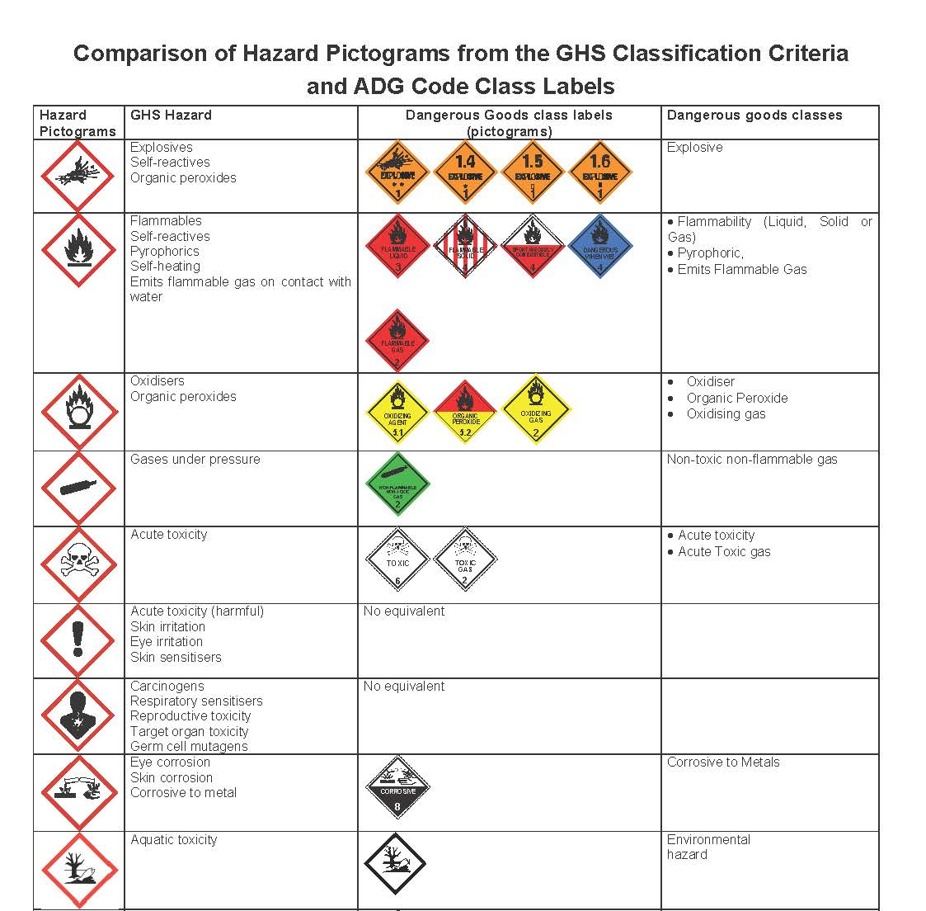

44. Look at the table above and answer the two (2) questions below:
a) Circle two (2) GHS hazard pictograms that have no equivalent in the Australian Dangerous Goods (AQG) class labels

b) list one (1) GHS hazard for each of the pictograms you circled in the above question.

________________________________________________________________________

WHS, Risks & Hazards
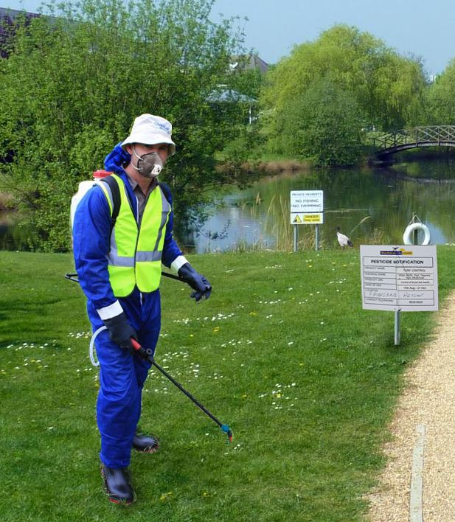
- What is the HAZARD in the image to the right?
- The chemical being sprayed
- No face mask/respirator
- Off target drift
- PPE
- What is the main RISK in the image to the right?
- Heat exhaustion
- PPE failure
- Off target drift into public lake
Operator spraying a Poison (S6 chemical)
that is harmful to aquatic life
- Spraying chemicals
- What two (2) risks could occur in the manual handling of a 20L drum?
________________________________________________________________________

________________________________________________________________________
- What are two (2) risks to humans, arising from chemical application that need to be controlled?
________________________________________________________________________

________________________________________________________________________

- What is an example of a hazard or a risk in chemical application to each of the following?
- The environment
_____________________________________________________________________

- Plants
_____________________________________________________________________

- Animals
_____________________________________________________________________
- Complete the following table detailing the hazards and risks and controls for each chemical
Chemical | Hazards and risks | Controls

- What are the five (5) steps in the emergency procedures for chemical spills and incidents?
________________________________________________________________________________________________________________________________________________
________________________________________________________________________________________________________________________________________________________________________________________________________________________
- List the five (5) steps in cleaning chemical spills?
________________________________________________________________________________________________________________________________________________
________________________________________________________________________________________________________________________________________________________________________________________________________________________
- What are the requirements for the clean up of equipment, after chemical use?
________________________________________________________________________
________________________________________________________________________

PPE, Storage & Disposal

- What are five (5) things you can do to ensure safe handling chemicals?
________________________________________________________________________________________________________________________________________________
________________________________________________________________________________________________________________________________________________________________________________________________________________________

- Tick all the items below that are best practice in maintaining a chemical storage area?
- Keep floor clean
- Keep PPE close to chemicals
- No items blocking walkways
- Flammable segregated from non-flammable
- Store granules above liquids
- Store pesticides and fertilizers together
- Store dog food in chemical shed
- Don’t overload shelves

- What are two (2) risks of not handling storing chemicals correctly?
_______________________________________________________________________________________________________________________________________________
- What are the legislative bunding requirements for storing chemicals, according to Australian standards?
- 100% of all liquid chemical in the chemical shed
- 100% of the largest bulk container or 25% of the total volume stored in drums (packaged goods)
- At least 3cm deep
- At least 50% of the floor covered

- Maintaining registers of stored chemicals and SDS (indicate all correct responses):

a) can be in hard copy or soft copy

b) is optional

c) is only required hazardous chemicals

d) needs to detail training staff have undertaken relating to hazardous chemical handling

59. Why is it necessary to maintain a register of hazardous chemicals and SDS in the workplace?
______________________________________________________________________________________________________________________________________________________

60. What are six (6) general principles for the safe handling and storage of hazardous chemicals?
______________________________________________________________________________________________________________________________________________________
______________________________________________________________________________________________________________________________________________________
______________________________________________________________________________________________________________________________________________________

61. List the four (4) steps you would follow to prepare a 20 L plastic pesticide drum for disposal under the “drum Muster” scheme
______________________________________________________________________________________________________________________________________________________
______________________________________________________________________________________________________________________________________________________

62. How would you dispose of excess, unwanted or expired chemical that is still currently registered?
___________________________________________________________________________
- What are the requirements for disposal of excess/expired/obsolete(unregistered) chemicals?
______________________________________________________________________________________________________________________________________________________
______________________________________________________________________________________________________________________________________________________

64. What monitoring and type of records need to be maintained in relation to the disposal of current and expired hazardous chemicals?
______________________________________________________________________________________________________________________________________________________

Transport
65. Tick at least four (4) requirements you need to follow when transporting chemicals?
  - Original labelled container
  - Tarpaulins are an effective restraint system
  - Placards only required on Front of DG loads
  - Documentation and records for the load are carried in the vehicle
  - Less restraint is needed for short journeys
  - Store Manifest files in same spot as personal files
  - Load containers onto a vehicles nonslip floor
  - Incompatible goods are segregated
  - Chemicals are not transported inside the vehicle
  - Use Sisal or Manila Ropes
  - Relevant documents of Chemical purchased kept by reseller only
  - Mix waste chemicals in same storage container

66. Where can you access information regarding the safe transport of chemicals?
_______________________________________________________________________________________________________________________________________________________________________

67. When transporting chemicals (other than dangerous goods), it is a requirement to have the following inside the vehicle: Circle all correct answers

a) The labels from all of the chemicals

b) The Safety Data Sheets for all of the chemicals

c) Contact details for emergency services

d) Emergency equipment and procedures

68. Describe six (6) requirements for the safe transport of chemicals, some may be state specific?
_______________________________________________________________________________________________________________________________________________________________________________________________________________________________________________________________________________________________________________________________________________________________________________________________________________________________________________________________________________________________________________________

69. Indicate the regulation that requires placarding for transporting chemicals that are Dangerous Goods AND the regulation regarding placard requirements for storage of chemicals

a) Rural Lands Protection Act 1998

b) Australian Dangerous Goods Code Edition 7.6 for all states and Territories

c) Dangerous Good Act 1985

d) Occupational Health and Safety Regulation 1996 (WA) 2017 (Vic) /Work Health and Safety

Regulations elsewhere

70. You have safely loaded and secured 5 x 200L (1000L total) drums of Gasoline (petrol) for transport.

The SDS extract provides the following DG transport information about Gasoline.

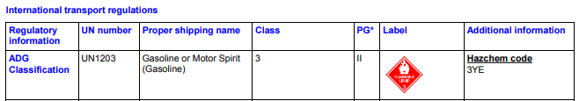

Using the SDS information above and information in the manual, answer the following questions:
- Is placarding required for this load? _______________________

- If required, which placard/s need to be displayed on the transport vehicle (Circle those that apply)?

 | 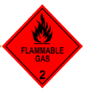 | 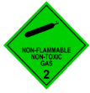 | 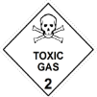 | 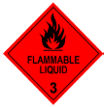 |  | 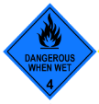
EXPLOSIVE  1 | FLAMMABLE GAS  2 | NON – FLAMMABLE  NON-TOXIC GAS  2 | TOXIC GAS  2 | FLAMMABLE LIQUID  3 | FLAMMABLE SOLID  4 | DANGEROUS WHEN WET  4
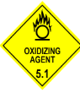  OXIDIZING AGENT  5.1 | 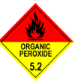ORGANIC PEROXIDE  5.2 | 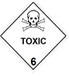  TOXIC  6 | 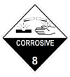  CORROSIVE  8 | MISCELLANEOUS GOODS  9 | DANGEROUS  GOODS

- Would you require a transport manifest/transport documents for this load?
______________

Application, Spray Drift and Calibration
71. Why is it important to check and monitor the weather conditions prior to applying chemicals?
______________________________________________________________________________________________________________________________________________________________________________________________________________________________________________________________________________________________________________________________________________

72. What are two (2) ways you can check the suitability of weather conditions to chemical application?
_______________________________________________________________________________________________________________________________________________________________________

73. For each of the following weather conditions explain the possible impact of safe and effective application of chemicals

Weather factor | Possible impact
High humidity
Low humidity
High wind speed
Atmospheric stability (including up and down air currents)
Rain

- Explain how each of the following factors contribute to off target damage:

Factor | Contribution to off target damage
Physical movement of chemicals (animals moving bait or soil moving)
Chemical formulation
Wind speed and direction
Temperature and relative humidity
Temperature inversions
Rain
Buffer zones and barriers

75. Circle the WORST weather conditions for spraying chemicals, in regard to spray drift:

a) sunny day, 10km/hr wind

b) spraying at night with no wind or cloud cover

c) cool overcast day

d) low winds, low temperature and high humidity

76. Identify two (2) practices that may help to manage drift of droplets and vapour when spraying

a) spraying when wind speed is greater than 3 kph but less than 15 kph

b) increasing the spraying pressure

c) spraying when conditions of temperature inversion occur

d) spraying in temperatures above 30°C

e) spraying when the Delta T value is less than 10 and above 2°C

f) increasing ground speed of equipment

77.What are four (4) strategies you can put in place to control off target damage?
________________________________________________________________________________________________________________________________________________________________________________________________________________________________________________________________________
78.What are the off target risks for each of the following application methods?
Application method | Off target risk
Seed treatments
Spray application
Baits
Boom sprayer
Aerial sprayer

- Following January rains on fallow ground, you are intending to use 2,4D. Looking at the TeeJet nozzle chart, CIRCLE the nozzle type, size and pressure that delivers a water rate around 80 L/ha, (don’t exceed 5 bar pressure), working on an average travel (application) speed of 18 km/h with a 50 cm boom height, and answer the questions below:
Note: APVMA advises “for cereals, fallow and pastures from 03/10 to 15/04 use nozzles that produce Extremely Coarse (XC) to Ultra Coarse (UC) droplets.”

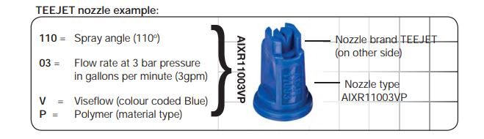
  - Nozzle type and size (i.e. XR11003-VP)
___________________________________________________________________
  - Droplet size (C, VC, XC, UC and Bar pressure (between 3 to 5 bar)
___________________________________________________________________
- Travel speed and water rate (L/ha)
___________________________________________________________________
___________________________________________________________________
80. What are the signage requirements when using chemicals in public places?
________________________________________________________________________

81. List the three (3) types of placards (warning signs) required under the WHS regulation
________________________________________________________________________
________________________________________________________________________
________________________________________________________________________

82. List three (3) reasons for keeping records of pesticide use
________________________________________________________________________
________________________________________________________________________
________________________________________________________________________

83. List two (2) examples of records that are required in regards to chemical use?
________________________________________________________________________
________________________________________________________________________

Activity 2: Activities and Spray plan

WHS Transport Incident

Instructions to Student
Read the following case study and complete the report.

Case study: Workplace safety transport incident
Read the case study and complete the incident report

On the 20th April 2019, you and your co-worker Bill Smith have just arrived at your worksite at Linton Park, Gladbrooke. You park the work ute near the chemical shed as you are transporting a pallet of 9 x 20L drums full of Chlorpyrifos 500 EC..
2:15pm - Bill Smith opens the tray to the ute and doesn’t realise a drum is loose as he was distracted looking at his phone. The drum rolls out of the back of the ute and Bill tries to catch it in his arms. The drum is heavy, hits Bill’s arm before he can catch it and drops heavily onto his foot
Bill falls to the ground but luckily the chemical drum has not spilled. He has some pain in his left arm, but strong pain in his right foot.
As he cannot walk on his foot (or hold his weight) is taken to hospital for x-rays at 2:35.
Safe work is notified of the incident at 5pm when the company is told that Bill has fractured his foot and will need 3 weeks off work.

COWORKER ID:

Name: Bill Smith
Date of Birth: 1/02/79
Gender: MALE
Address: 22 Tipster St Roma 4455

Work Health & Safety Incident Report Form
Details of the person completing the report | Name:
 | Contact phone number:
Time and date of incident
Location of incident
Activity being undertaken
Brief description of incident / near miss
 | Name: ______________________________________________________
Details of injured person
 | Gender: □Male □Female Date of Birth:
Mechanism of Injury  (indicate all relevant) | □Slip/trip/fall □Manual handling □Body stressing □Being hit by falling object
 | □Hitting an objects with part of the body □Being hit by moving objects
 | □Exposure to Chemical agent □Exposure to asbestos □Exposure to work stress
 | □Violence □Other inappropriate behaviour □Other: _______________________________
Nature of Injury  (indicate all relevant) | □Sprain/Strain □Fracture □Cuts/Scratch/Abrasion □Bruising □Burn
 | □Electrical shock □Concussion □Psychological □Other ___________________________

Body Location/s: | 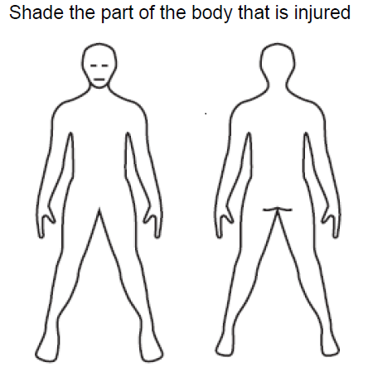
 | □No treatment □First Aid □Doctor □Hospital outpatient □Hospital admission
Treatment required | □Other ___________________________________________________
What were the contributing factors (if any)?
What controls can be put in place to prevent this from happening again?
Is this a notifiable incident?  (refer to Work Health & Safety Incident Investigation Guide) | □Yes. Date Notified:
 | □No
Signature: ____________________________ Date: ___ / ___ / _____
Name: _______________________________________________________

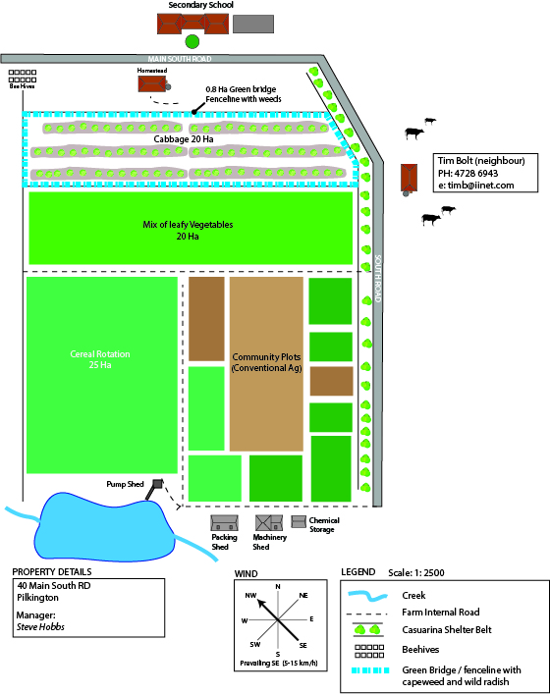
Spray Plan activity
Use the information provided below and ONE of product Labels
provided to complete the Property Spray Plan and Risk Assessment.

Looking at the property map and the Movento chemical label for crop 1
(
treating young Diamondback moth (DBM) larvae)
OR the
glyphosate 450 label for controlling weeds in the green bridge
surrounding the cabbages (shown in diagram in blue as area 2),
read the scenario and fill in the Spray plan.

You are working as a spray applicator and have been asked by the manager to spray EITHER crop 1 or area 2 at the property Community Holdings. The property you are working on is located at 40 Main South Road, Pilkington.

Crop 1: 20 Ha Cabbages (6 to 8 leaf stage) needs to be treated for Diamond Back Moth larvae (preferably first instar) using Movento 240 SC insecticide and an adjuvant as per label. The label specifies 2 sprays; 7 to 10 days apart in spring as soon as eggs hatch with a medium spray quality.

Area 2: Green bridge of weeds on perimeter of cabbages adjacent to fence line, approximately 0.8 ha in total area, requires treatment for capeweed and spear thistles currently growing in the area using Glyphosate 450 herbicide. These weeds are providing harbour for insect pests and are currently infested with DBM larvae.

The property has a recently calibrated 15 m boomspray with TTJ6011004 nozzles, (operated at 4 bar and 6 km/h) as well as a 15-litre knapsack available for use.

The chemshed holds 2x10 Litres of Movento SC and 2x 20 litres of Glyphosate 450.

Ph 0456238175
ChemCert Training Group AQF3 Assessment 40
Property Spray Plan: (property and date) ____________________________________________

Notes:
- This plan can be either prepared by the owner, occupier, or manager of the property, or the applicator.
- The purpose of this plan is to provide information to potentially affected parties on planned spraying activity. Note that actual spraying may differ from this plan, but this is a best estimate given current circumstances.
- Provision of this information does not imply a right of any party to object to spraying activities occurring legitimately within the subject property boundary.
ChemCert Training Group AQF3 Assessment 41
 | Name | Address (postal/physical) | Email and phone/ Numbers
Property Owner(s)/Occupier(s) | Community Holdings LTD. | 40 Main South Road, Pilkington | Communityholdings@gmail.com  88777788
Property Manager  (if not owner/occupier) | Steven Hobbs | 40 Main South Road, Pilkington | 0456238175
Applicator
Application method and nozzle:

Target crop to be sprayed  e.g. apples, wheat | Area to be sprayed (show on map of property) | Times of year spraying likely to occur  e.g. month or crop stage | Agrichemical to be used e.g. insecticide, herbicide, fungicide; plus adjuvant Product name | Application, rate, water rate, speed and pressure | Specific hazards  e.g. toxicity to bees

Sensitive Areas –  circle on map for both applications and list below  (description and location of neighbouring crops/schools/houses/roads - especially those used by children such as school bus routes) | Factors to consider before spraying and  Measures to be used to avoid contamination of sensitive areas  (eg low drift nozzles, no-spray buffer zones, favourable wind direction, school holidays)

ChemCert Training Group AQF3 Assessment 42
Neighbour’s name | Address (postal/physical)  - mark on map below | Email and phone/fax numbers | Status: owner/occupier  Type of property (eg school, residence, orchard) | Notification:  date and method  (note if phone call prior to spraying requested)

Risk Assessment: Outline the activity and the associated risk levels in the spraying/application procedure (including clean up and disposal).

Equipment required:
ChemCert Training Group AQF3 Assessment 43
Crop/site. | Description of activity | Frequency of task |  | Level of Risk Rating –  with no controls in place | Controls required |  | Level of Risk Rating –  with all controls in place | Comments
 |  |  | Consequence score Likelihood score | Extreme  High  Medium  Low |  | Consequence score Likelihood score | Extreme  High  Medium  Low

Recordkeeping sheet: Chemical Use

Boomspray Option: Following through with the spray plan, you started boom spraying the cabbages at 9am and finished at 11.00 am, using your 15 m boomspray and TTJ6011004 nozzles at 4 bar and 6 km/hr, in the weather you recorded outside. Refer to the TeeJet nozzle flow rate chart on page 33 for the boomspray output at the pressure and speed shown above.

Knapsack Option: A calibration determined a knapsack output of 250 ml/10 square meters, ie 250 L/ha so use this value to determine total water needed for the green bridge weed spraying, which started at 8am and finished at 12.30 pm.

ChemCert Training Group AQF3 Assessment 44
 |  |  |  |  |  |  |  | Weather Details* |  | Contact Details
Date of application | Product Trade Name | Start/Finish times | Total chemical mix | Crop/commodity treated OR situation product | Extent of use (area/volume/  weight) | Location where product was used | Wind direction | Wind speed | Temperature | Name and address of person for whom the application was carried out

Hazardous Chemical Register

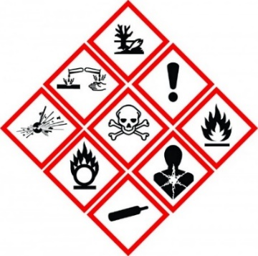
A Hazardous chemical register is a list of all hazardous chemicals used, handled or stored at your workplace. You must keep the current safety data sheet (SDS) with this register and make sure it is accessible to workers. The SDS will tell you how to use and manage hazardous chemicals safely. The supplier of your chemicals should provide a SDS on request. Note: Chemicals not classified as hazardous chemicals do not require SDSs and do not need be included in this register.
How can you tell if a chemical is classed as hazardous?
Section 2 of the SDS will tell you if, and how the chemical is hazardous. Other indications are:
- The manufacturer or supplier provided a copy of the SDS with the chemical
- The label of the product includes:
  - diamond-shaped warning pictograms (see right)
  - signal words Danger or Warning
  - hazard or precautionary statements such as Toxic if swallowed and Wear eye protection
  - risk or safety phrases such as Harmful if swallowed and Keep out of the reach of children.
Contact the manufacturer or supplier for more details or for a copy of the SDS. Many companies also provide SDSs online.

Chemical name | Manufacturer  including Australian contact details | SDS issue date  (must be <5 years)  Month / Year | Maximum quantity held on site | Comments (Describe two classifications from SDS section 2.1 and Signal Word from 2.2
(source: https://www.worksafe.qld.gov.au/.../hazardous-chemical-register.docx)
ChemCert Training Group AQF3 Assessment 45

Activity 3: Practical

Instructions to Student

The following tasks are to be undertaken in a simulated workplace (outdoors at a venue) and observed by the assessor. This assessment is to follow on from the Spray plan completed prior.

The assessor is to explain the scenario and the steps to be taken. The student completes the checklist below and the trainer then completes the “Practical Observation Checklist” for each task for each student. Any criteria deemed not satisfactory must be reassessed.

Practical Assessment
1.Load/unload chemicals from back of ute tray and check for chemical expiry/Date of Manufacture (DOM)
2.Based on the scenario your trainer has given you (and on the spray plan you completed in activity 2), what chemical have you chosen to apply:
_____________________________________________________________
3.What equipment have you chosen to apply the chemical with:
_____________________________________________________________
4.Conduct pre-operation check of your equipment
5.Check weather and fill in the details below:
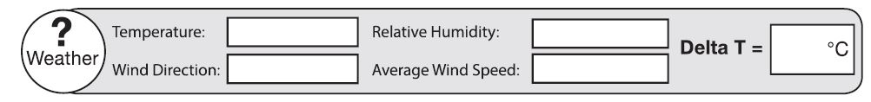

6.Pick PPE will you need to wear when applying your chosen chemical:
_____________________________________________________________
_____________________________________________________________
7. Measure and mix simulated chemical and water required as per label rate. How much simulated chemical and water do you need?
_____________________________________________________________
_____________________________________________________________
8. What is the output measured?
9. Conduct calibration for knapsack OR boom.
A) Knapsack calibration
Using the Glyphosate boomspray rate for capeweed and spear thistles (less than 15 cms in size) of 1.6 L/ha, calculate the chemical concentrate to put in a 15 litre knapsack based on your sprayer output as measured in a jug over a 2x5 M area as per the calibration exercise shown below:

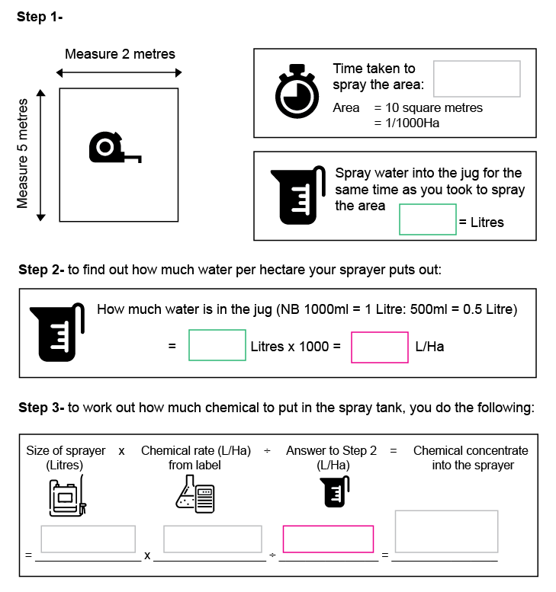
B) Boomspray calibration for 15 m boomspray (linkage with 1000 litre tank)
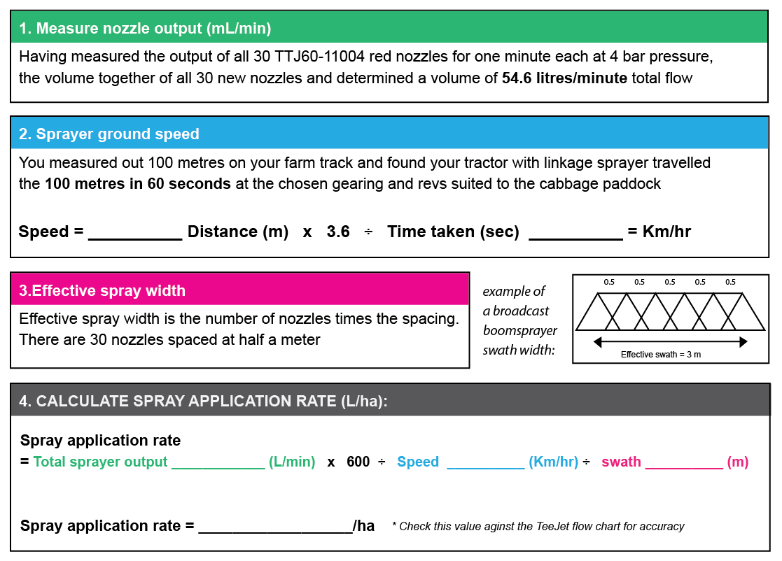

9.Conduct spill clean- up and fill in Spill Incident Report Form
Spill Incident Report Form
General details
Date: |  | Time:
Reported by: |  | Witnessed by:
Name: |  | Name:
Position |  | Position
Company: |  | Company:
Phone number: |  | Phone number:
Spill info
Is this a spill? | Y / N
Amount (mL or L):
Chemical/ Material:
Area affected (m2):
Surface type: | Concrete / Grass / Asphalt / Sand / Soil / Other
Did the spill go into a waterway or drain? |  | Y / N
Spill kit used: | Y / N
Incident description
Incident address:
Incident description:
Cause of incident or contributing factors:
.

Measures that could be implemented to prevent/minimise this incident in the future
Notification
Parties notified:
Name:
Position
Date:

- Clean equipment and PPE and decontamination
- How would you dispose of obsolete or expired chemicals and chemical drums?
Chemicals - _________________________________________________
Drums - ___________________________________________________

- What are four (4) aspects required for maintaining a chemical shed?
_____________________________________________________________
_____________________________________________________________
_____________________________________________________________
_____________________________________________________________

